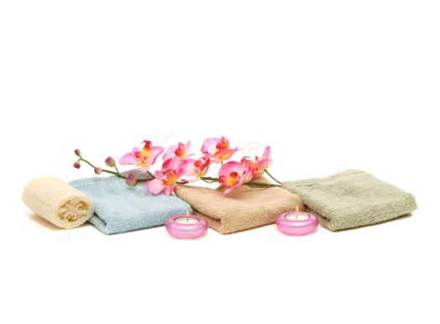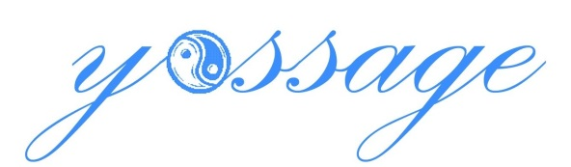

**Spa Menu**

**Custom Massage: Our signature massage incorporates a variety of techniques to help promote relaxation, increase circulation and reduce stress. Our therapists will tailor your treatment to best accommodate your requests.**

**60min: $115 90 min: $165**

**Aromatherapy Massage: Enjoy an unsurpassed level of relaxation in this massage treatment. Feet are massaged with alpine essences and wrapped to deepen hydration. Make this truly your own experience with your choice of aromatherapy essential oils.**

**60min: $120 90 min: $170**

**Lavender Zen Body Scrub: Remedy jet lag or your shortage of sweet slumber in this balancing spa experience that includes a dry brush exfoliation, full body exfoliation with our Turkish Body Scrub infused with organic essential oils to energize your mind and body or to promote deep relaxation. Our soothing organic Lavender oil induces rest and relaxation. Scrub is immediately followed by a 30 minute massage.**

**60 min: $125**

**Freestyle Facial: A purely customized deep cleansing treatment for any skin type that includes a gentle exfoliating peel to refine skin texture, extractions, a deep-cleansing masque and infusion serum including raspberry, neroli and aloe vera to rejuvenate and nourish the skin.**

**60 min: $115**

**Refresher Facial: A deep cleansing introductory facial based on organic Moor Mud, which refines and remineralizes dull, lifeless skin. Includes a skin analysis and short massage of the face and shoulders, as well as a heated hand treatment.**

**30 min: $60**

**Ear Candling:** **Relax and unwind with this safe and effective procedure to gently remove excess ear wax and debris. A muslin candle dipped in beeswax is lit on one end while the other is placed in the ear. Soft heat warms the ear wax which is then pulled into the unburned portion of the candle. It takes about 15 minutes per candle, per ear, and it's recommended you not do more than two candles per ear in a single session.**

**Both ears: $45**

**Waxing: Smooth, silky skin awaits with face and body waxing. Discounts packages available with multiple areas being waxed on same visit.**

**Lip, Brow or Chin: $15 ea Arm (both): $35 Half Leg (both): $30**

**Underarm (both): $20 Bikini: $30 Full Leg (both): $50**

**Call or email for an appointment**

**Cash or Credit Cards accepted**

**mobile: 917-696-5728**

**email: yo@yossage.com**